**Database Management Systems Lab Experiment No: - 10 Aim: - Implementation of functions & procedures in SQL**

# Procedures:-

A procedure is a named PL/SQL block which performs one or more specific task. This is similar to a procedure in other programming languages. A procedure has a header and a body. The header consists of the name of the procedure and the parameters or variables passed to the procedure. The body consists or declaration section, execution section and exception section similar to a general PL/SQL Block. A procedure is similar to an anonymous PL/SQL Block but it is named for repeated usage.

We can pass parameters to procedures in three ways :

|  |  |
| --- | --- |
| **Parameters** | **Description** |
| IN type | These types of parameters are used to send values to stored procedures. |
| OUT type | These types of parameters are used to get values from stored procedures. This is similar to a return type in functions. |
| IN OUT type | These types of parameters are used to send values and get values from stored procedures. |

A procedure may or may not return any value.

# Examples :

**1)**

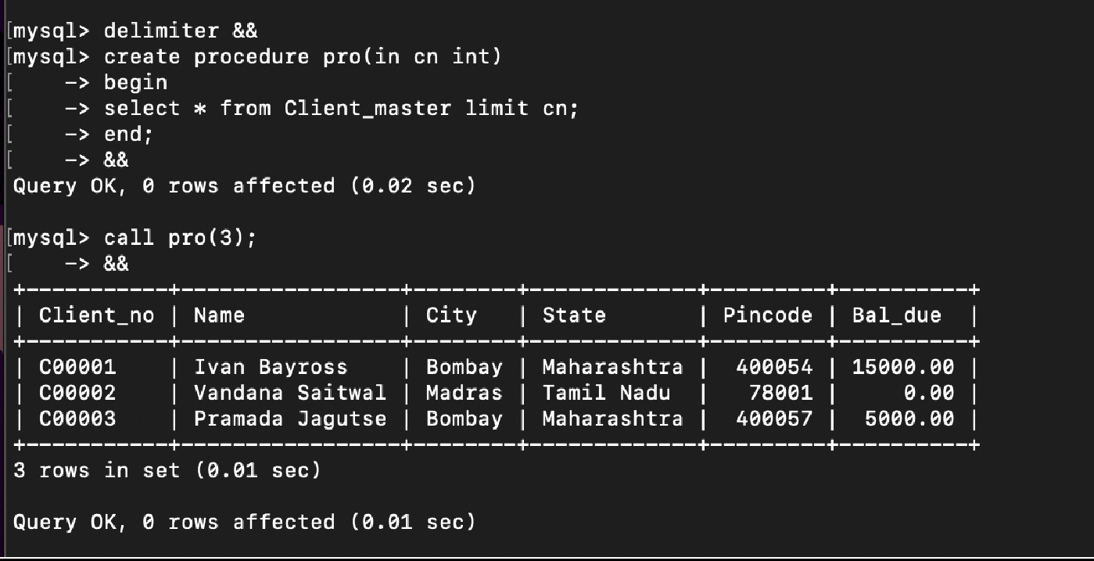

1

**Database Management Systems Lab Experiment No: - 10 Aim: - Implementation of functions & procedures in SQL**

# 2)

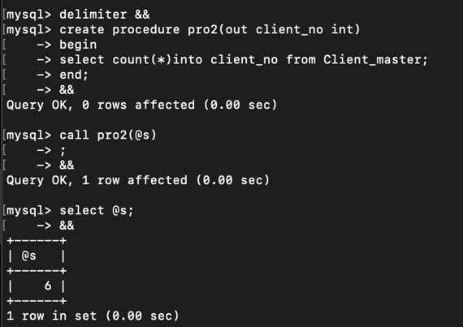

2

**Database Management Systems Lab Experiment No: - 10 Aim: - Implementation of functions & procedures in SQL**

# Functions:-

A function is a named PL/SQL Block which is similar to a procedure. The major difference between a procedure and a function is, a function must always return a value, but a procedure may or may not return a value.

# Query:



**Output:**

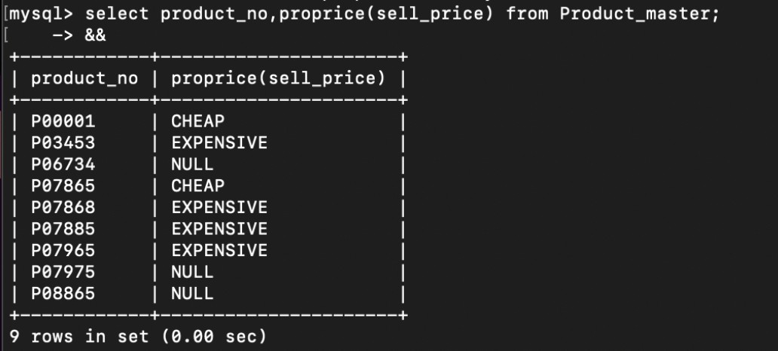

3

**Database Management Systems Lab Experiment No: - 10 Aim: - Implementation of functions & procedures in SQL**

# Query:

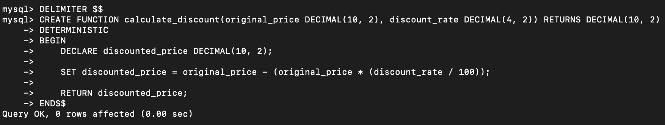

**Output:**

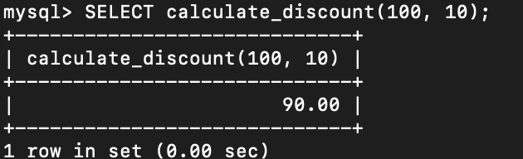

4

**Database Management Systems Lab Experiment No: - 10 Aim: - Implementation of functions & procedures in SQL**

# Procedures VS Functions:

* A function MUST return a value
* A procedure cannot return a value
* Procedures and functions can both return data in OUT and IN OUT parameters
* The return statement in a function returns control to the calling program and returns the results of the function
* The return statement of a procedure returns control to the calling program and cannot return a value
* Functions can be called from SQL, procedure cannot
* Functions are considered expressions, procedure are not

|  |  |  |  |  |  |  |
| --- | --- | --- | --- | --- | --- | --- |
| Functions | Procedures | | | | | |
| A function has a return type and returns a value. | A procedure does not have a return type. But it returns values using the OUT parameters. | | | | | |
| You cannot use a function with Data Manipulation queries. Only Select queries are allowed in functions. | You can use DML queries such as insert, update, select etc… with procedures. | | | | | |
| A function does not allow output parameters | A procedure parameters. | allows | both | input | and | output |
| You cannot manage transactions inside a function. | You can manage transactions inside a function. | | | | | |
| You cannot call stored procedures from a function | You can call a function from a stored procedure. | | | | | |
| You can call a function using a select statement. | You cannot call a procedure using select statements. | | | | | |

Conclusion:- LO mapped LO3, LO4.

5